**CIS 350**

**Virtual Meditation Android Application**

**Customer Handoff Document**

**Group Members: Alex Brashear, Oliver Manheim, Yaou Wang, David Zbarsky**

**User Manual**

The Virtual Meditation Application will show up on the “Apps” menu of the Android phone as “Meditation”

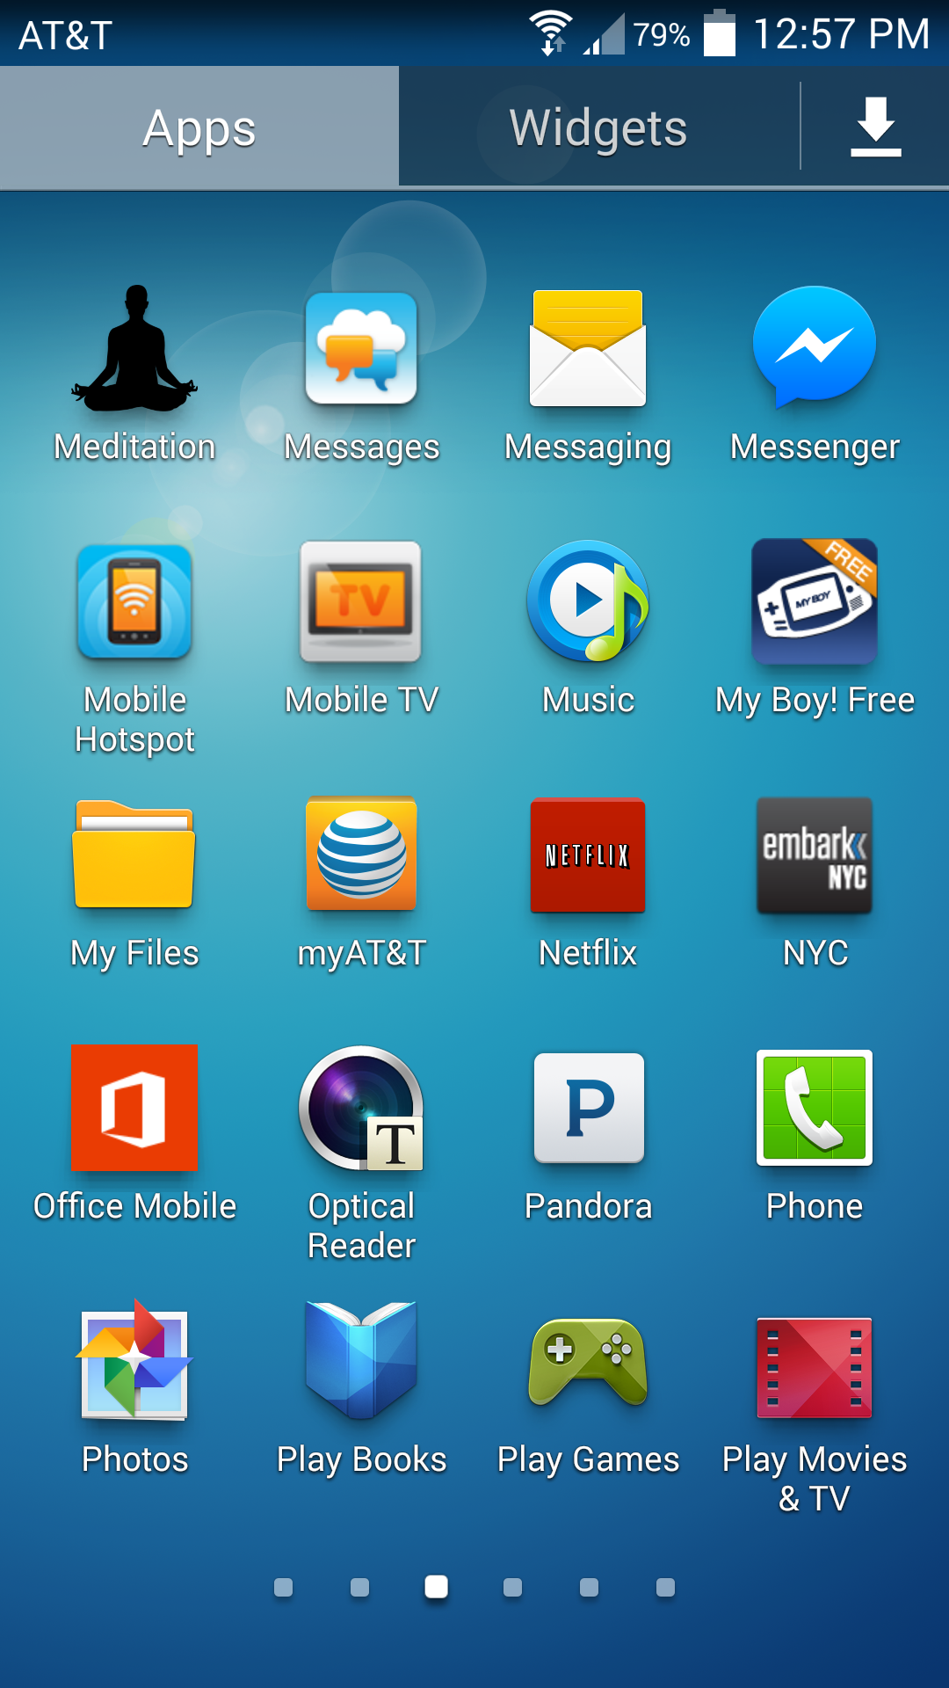

Figure

After clicking on it to open, the person will be guided towards a universal login page

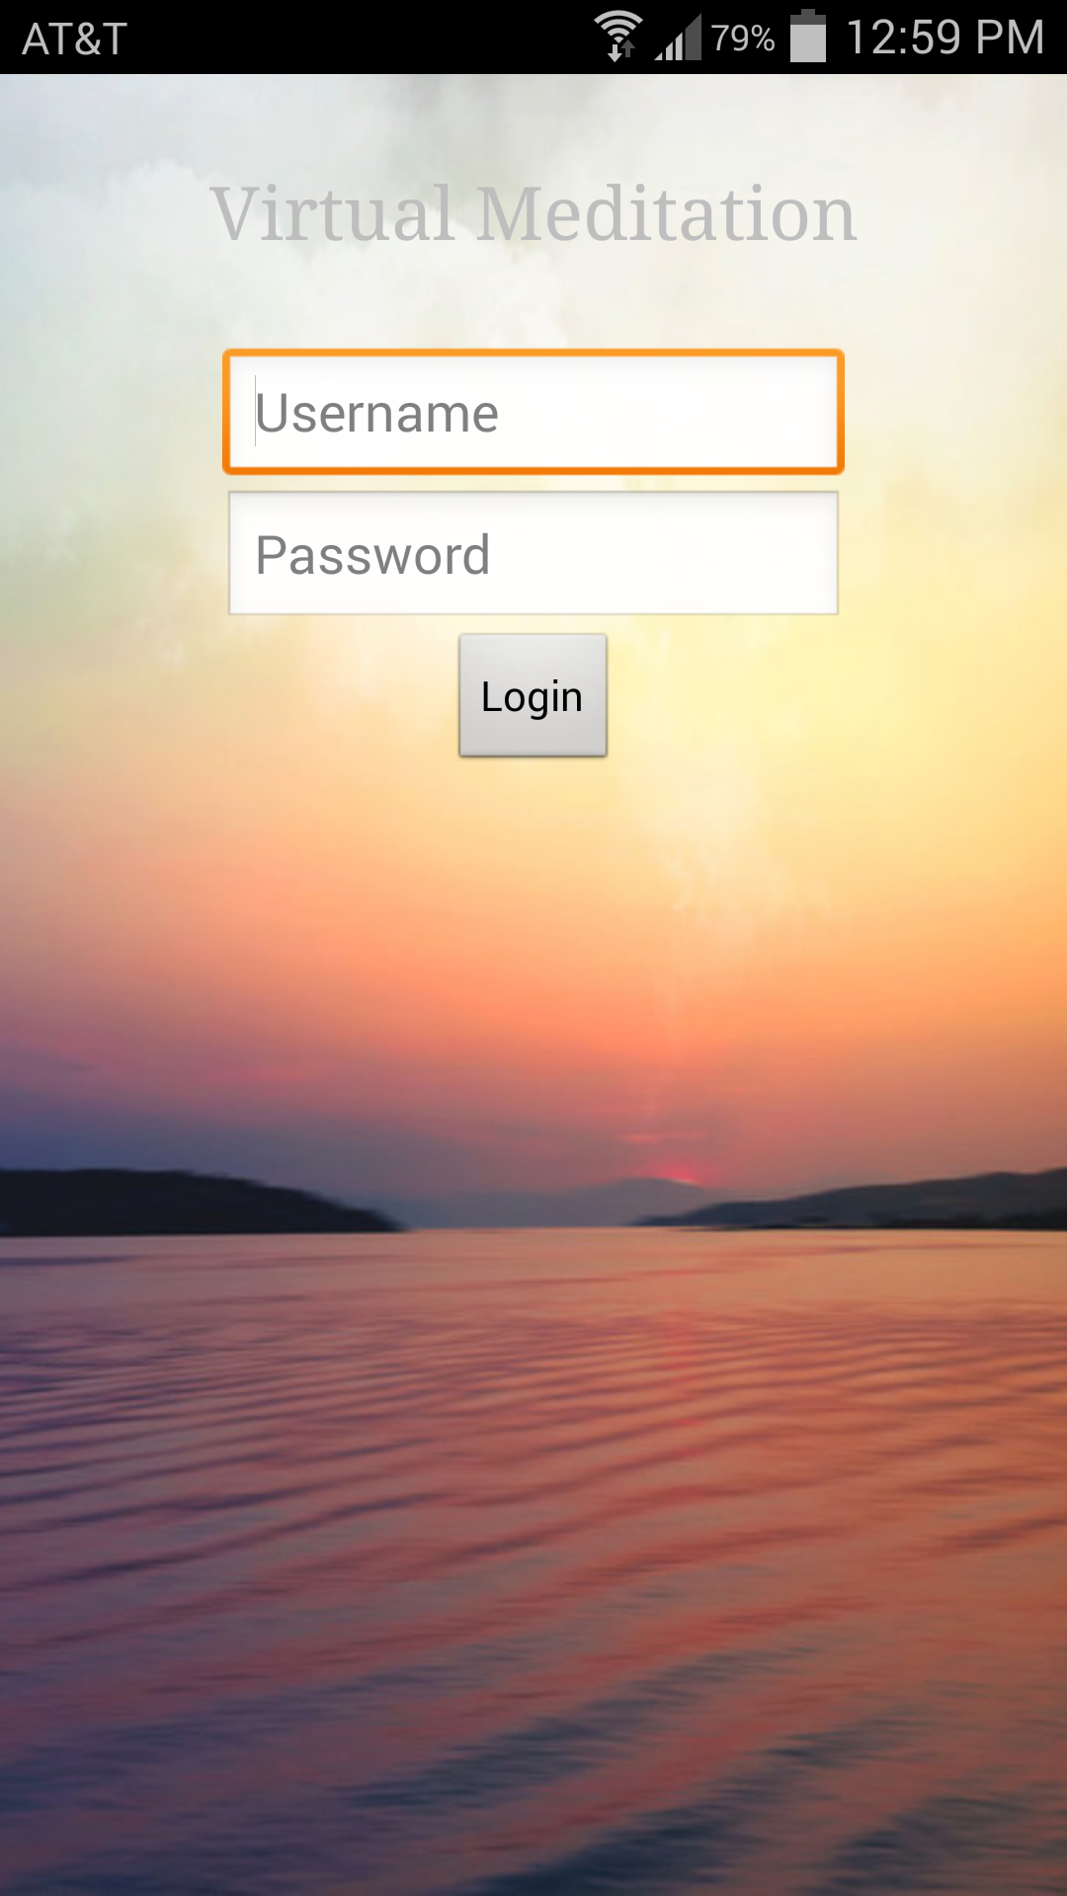

Figure

The Virtual Meditation Application has two modes: Instructor and User. Depending on the role the person is assigned to (i.e. an instructor that speaks and guides the meditation class or a user that participates in the conference), the application will open up different interfaces. We will now demonstrate screen by screen how to use each of the two modes.

User Mode:

After entering the appropriate user ID and password and clicking on the login button, the User will be directed to this screen (with a toast that says “Successfully logged in as participant”). Click the “Exit” button if the User wishes to exit the application. Otherwise, click on “Begin call” to start dialing into the meditation conference.

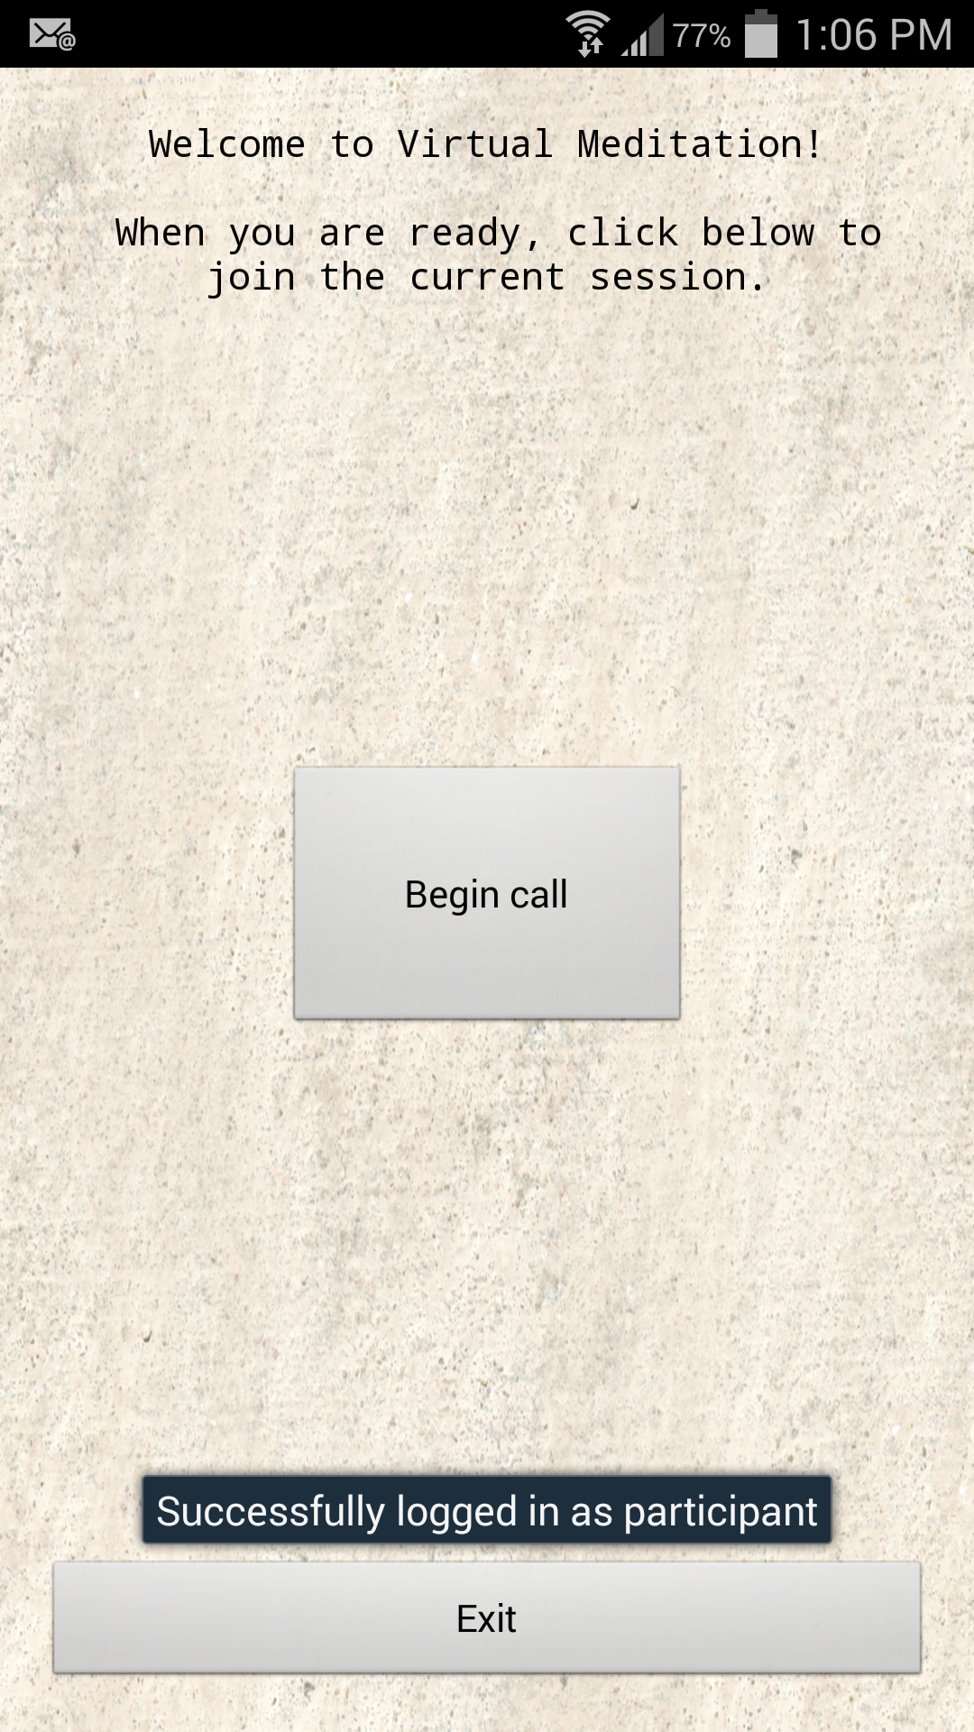

Figure

After clicking on “Begin call”, the User should see that a phone call is started and that the phone call screen has popped up. The User should put the phone on Speaker mode by clicking the Speaker button.

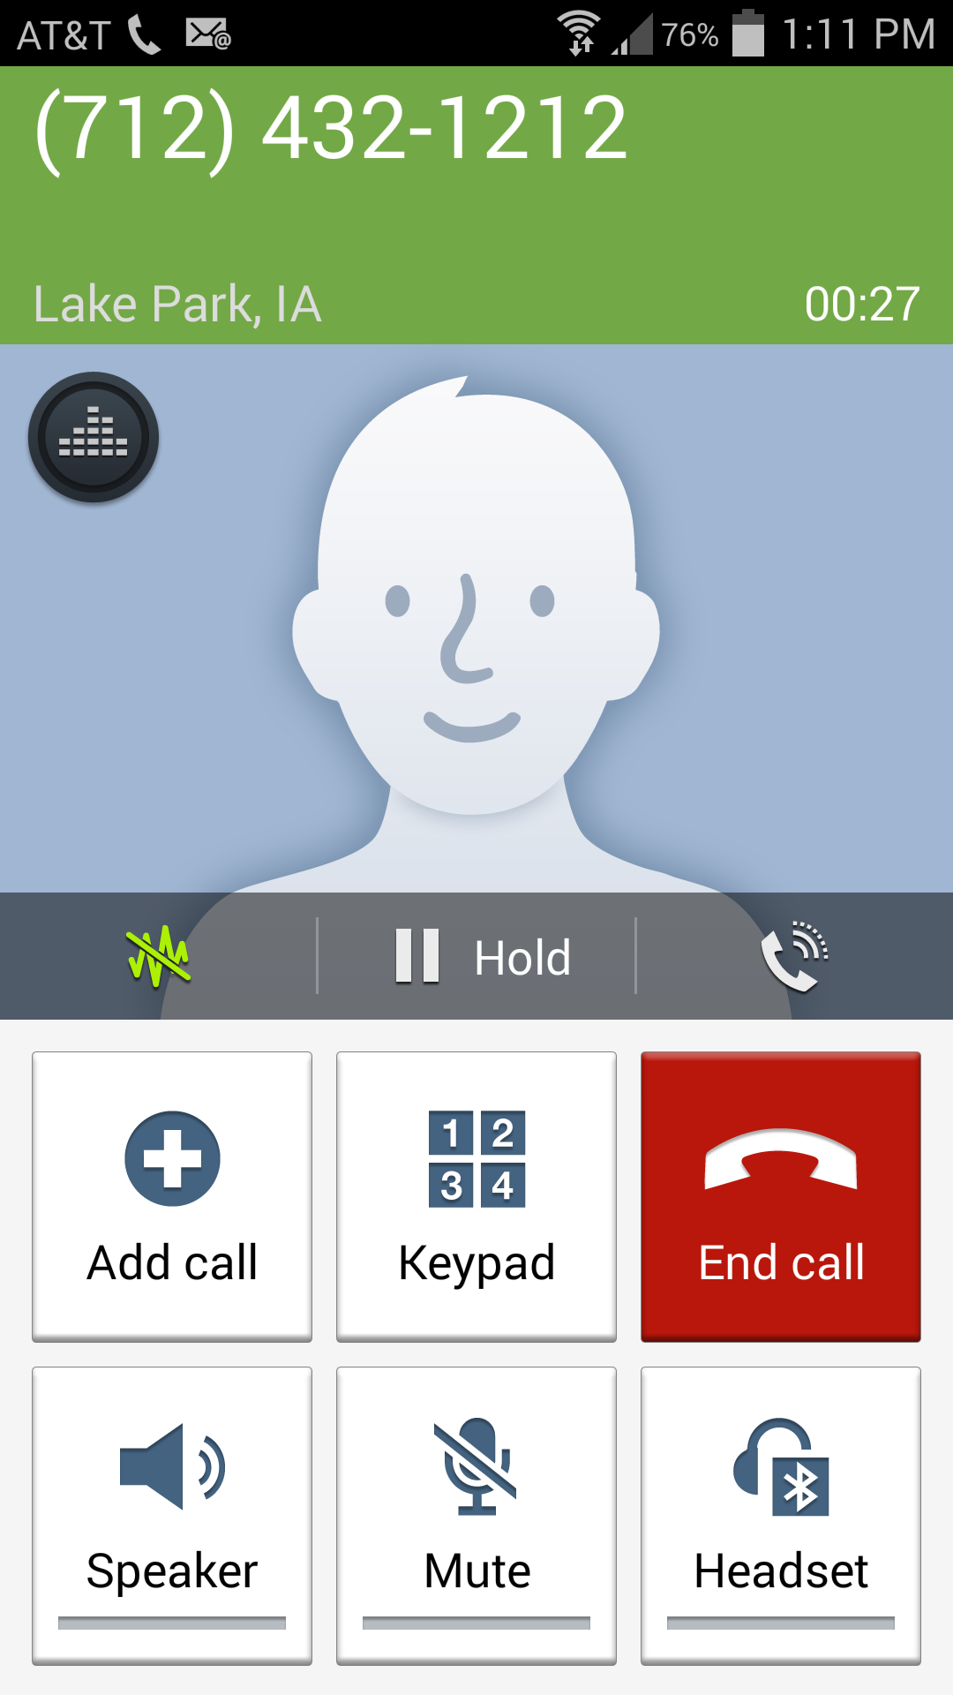

Figure

At this point the User should switch the activity from the phone call back to Virtual Meditation by holding down the Menu button until the following screen appears and clicking on the square beside “Meditation”

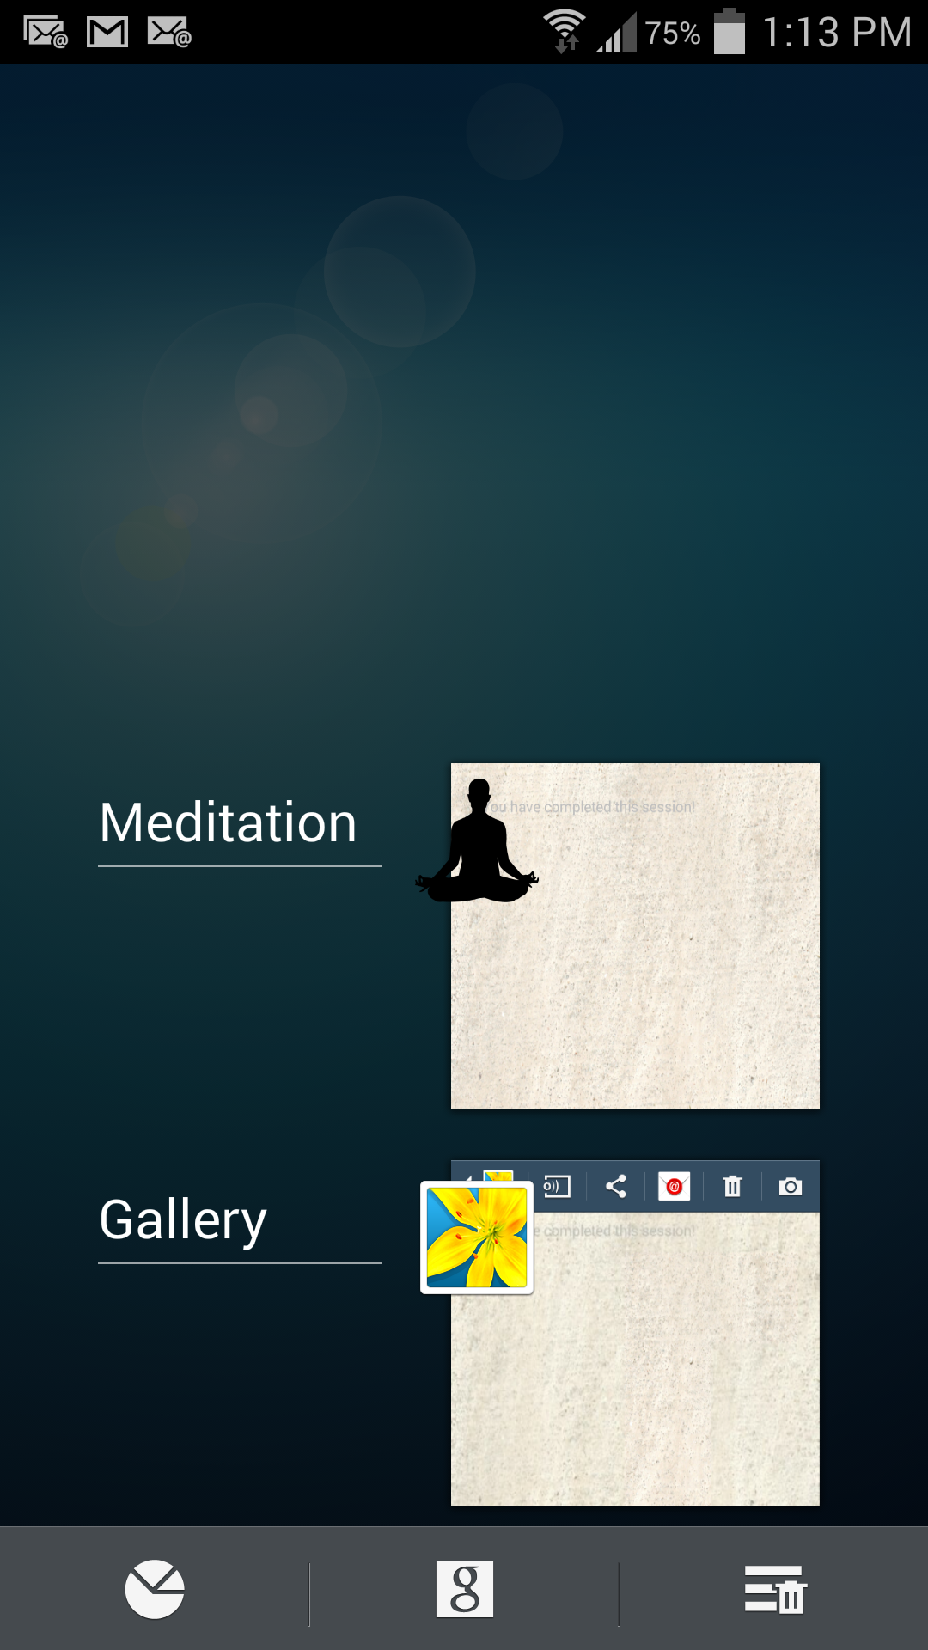

Figure

The User should be able to now listen in on the conference (via the phone call) and also ask questions to the Instructor via the following interface. There are standard questions (FAQs) on top which the user can just ask by clicking the corresponding button. Alternatively, the User can ask a custom question by typing the question in the text box and clicking the “Submit question” button (or by pressing Enter on the keyboard).

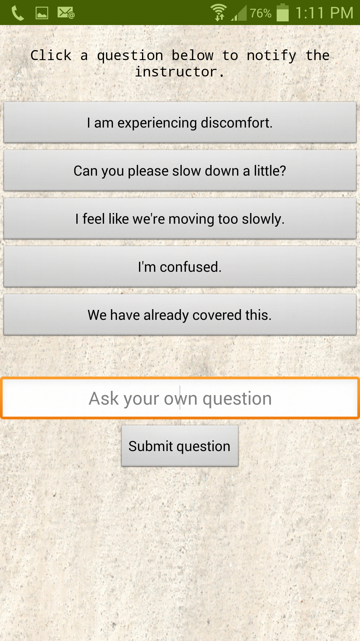

Figure

After the meditation conference ends, the user can exit the call (by hanging up from the menu bar on top) and will be redirected to the following session end screen.



Figure

The User can press the Back button to exit this screen and go back to the original post-login page:

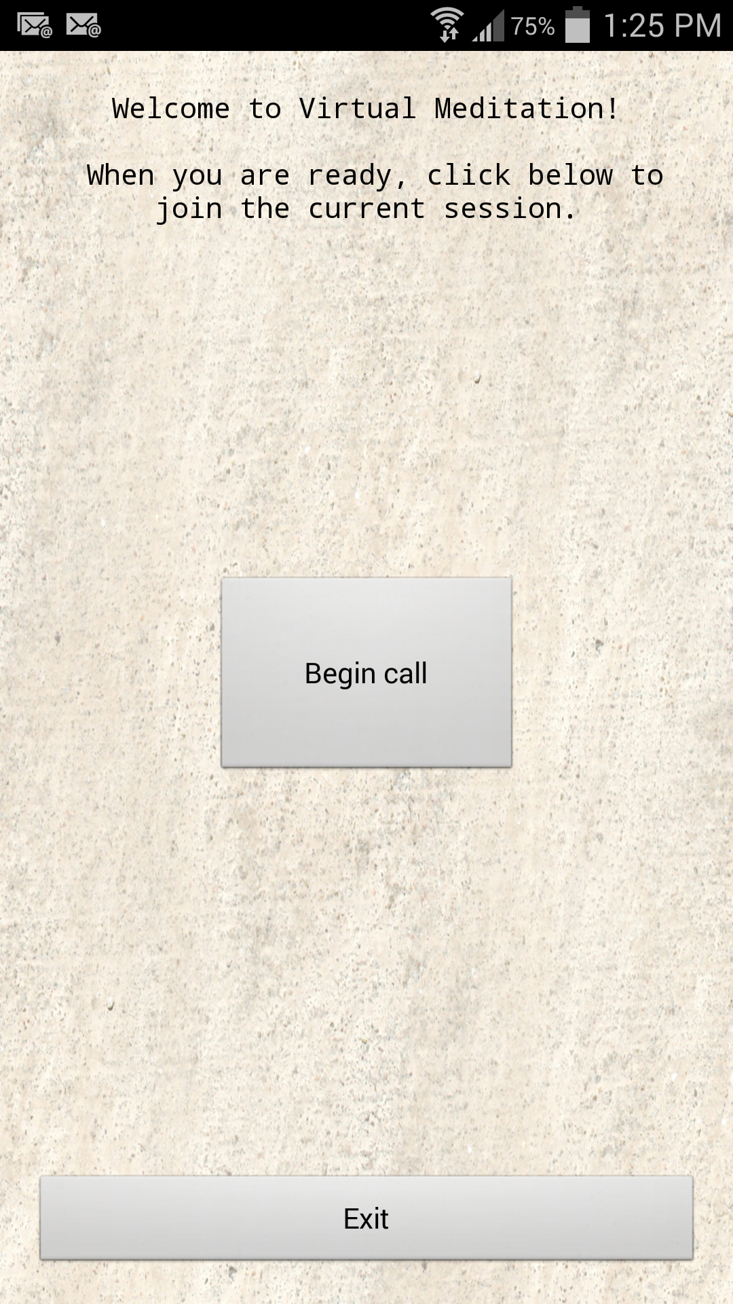

Figure

To exit, the User can click the Exit button.

Instructor Mode

After successfully logging in, the Instructor should see the following screen with a toast stating, “Successfully logged in as instructor”.

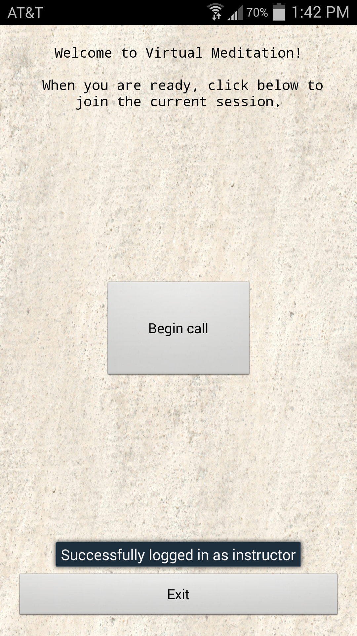

Figure

The “Begin call” and “Exit” buttons have the same functionalities as the comparable screen in User Mode.

After clicking on “Begin call”, the Instructor should see the phone call screen. The Instructor should also turn on speaker phone by clicking the Speaker button. At this point the Instructor should hear the dialing sounds of the Application automatically dialing in the conference call ID and the instructor ID. Furthermore, the Application will automatically mute all the users in the call (so the instructor should wait until all dial tones are finished and the conference call guide says “All participants muted”).



Figure

To see a list of other functions the Instructor can do by pressing the Keypad, please refer to the Appendix.

After setting up the conference to the Instructor’s desired configurations, the Instructor can return back to the Meditation App by the same procedure as the one described in Figure 5 of the User Mode instructions.

At this point the Instructor can start the meditation conference while also monitoring the users’ questions via the following screen. The upper half of the screen is a list of standard questions presented in histogram format, with plus signs indicating frequency. The bottom half of the screen corresponds to a list of submitted custom questions with the most recent ones on top. The Instructor can scroll through these custom questions.

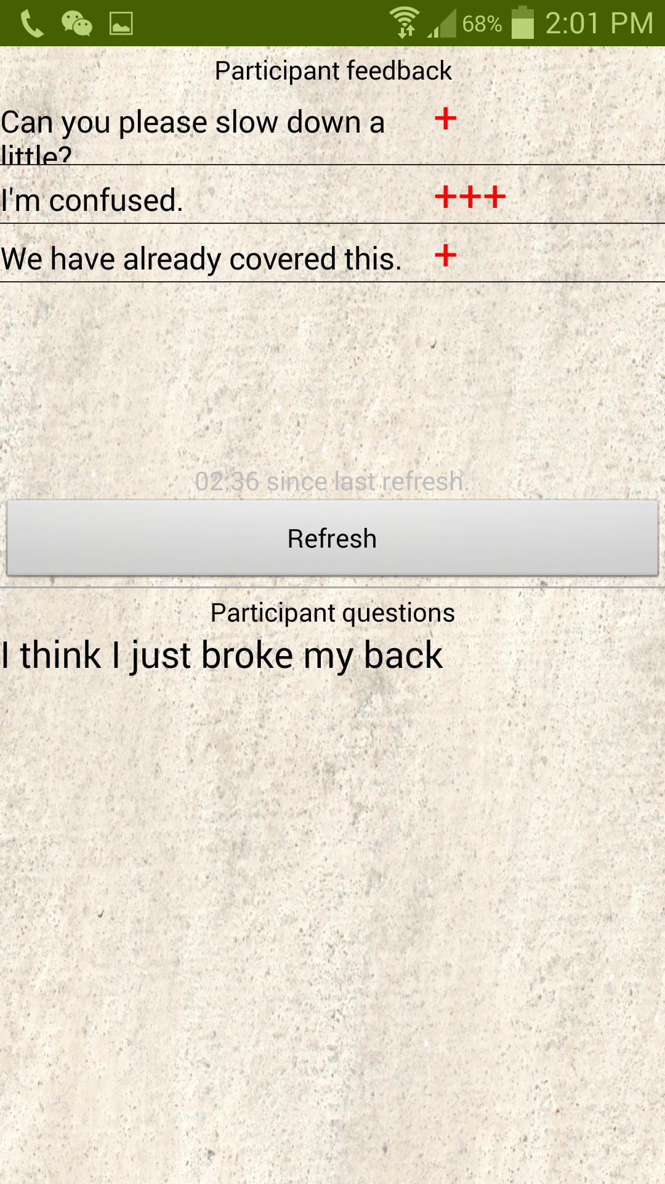

Figure

The “Refresh” button allows the Instructor to manually clear past questions in the standard questions panel (so that only questions asked after clicking Refresh will be visible). The time stamp on top of the button shows how long the time has passed since the last refresh. For example, after clicking “Refresh”, the Instructor will now see the following.

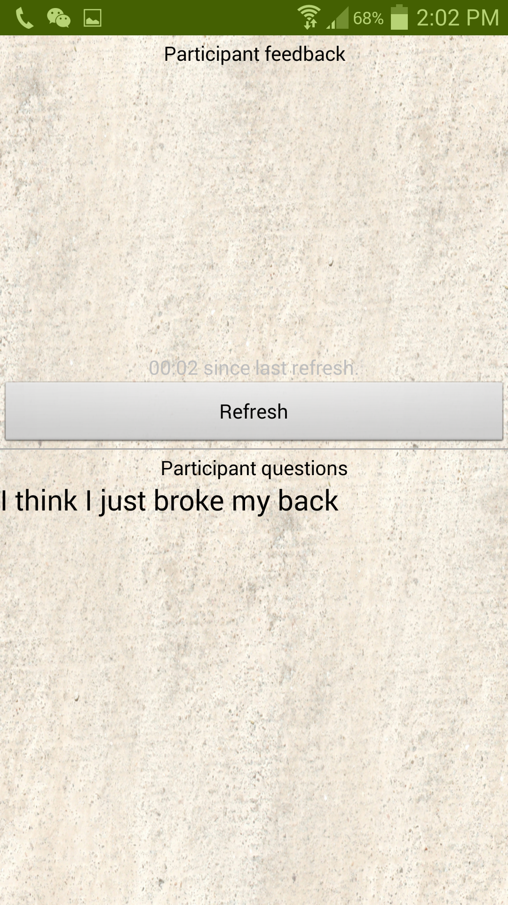

Figure

When the Instructor terminates the conference call and hangs up, he/she will automatically be guided to the following screen, where a list of all questions asked during the entire session is shown.

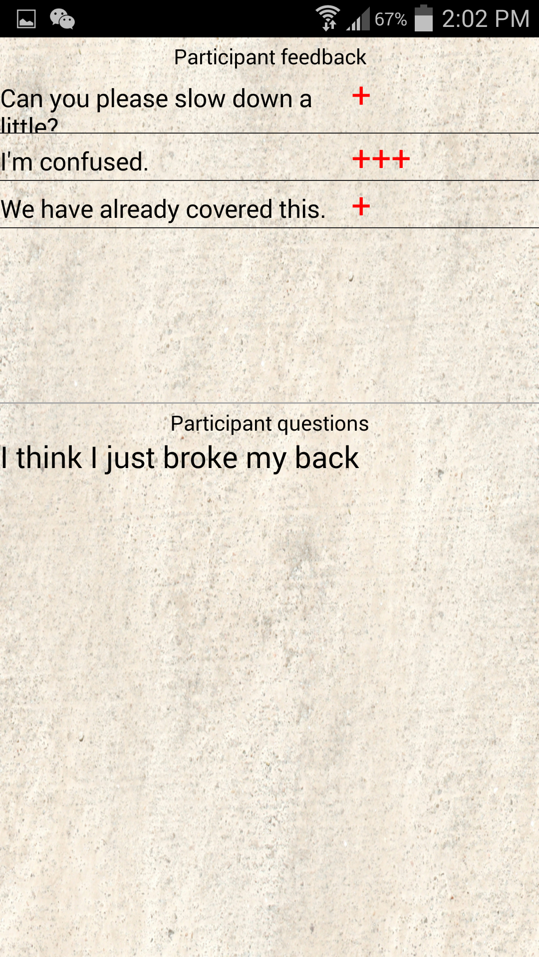

Figure

The Instructor may return to the landing screen by pressing the Back button.



Figure

The Instructor may exit by pressing the “Exit” button.

Appendix

This is a list of keypad instructions the Instructor may dial to change settings of the conference call. Instructor settings are listed under “Host Feature Keys” and User settings are listed under “Participant Feature Keys.” More detailed information can be found at <https://www.freeconferencecall.com/instructions>

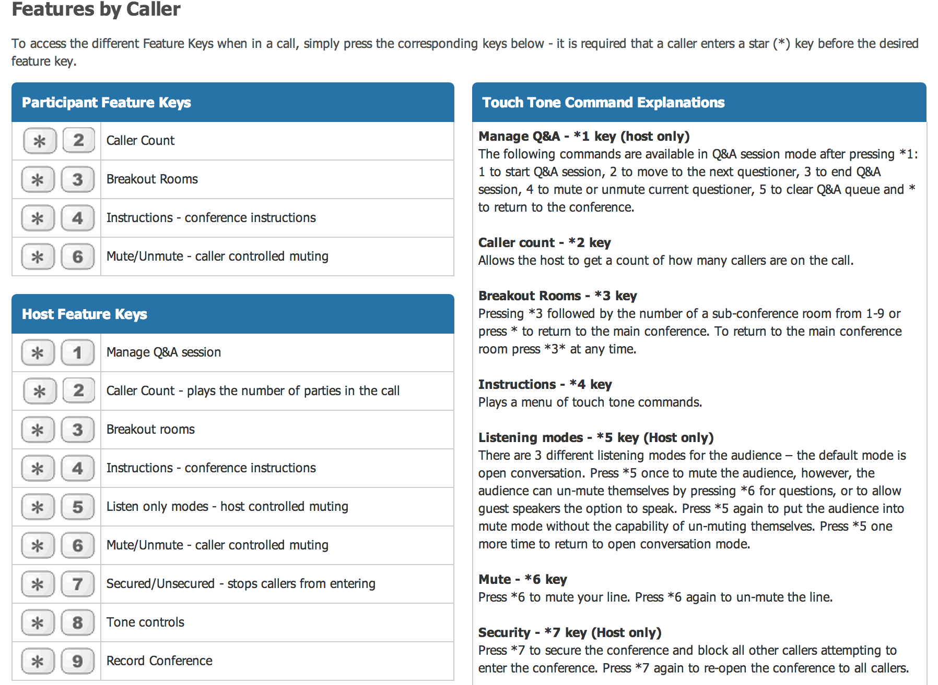

**Technical Documentation**

* All “*.java*” files will be located in the folder Meditation/src/com/example/meditation.
* All “*.xml*” files will be located in the folder Meditation/res/layout.

**Screen from User Manual:** *Figure 2*

This screen corresponds to *MainActivity.java* and the layout is *login.xml*.

**Screen from User Manual:** *Figure 3*

This screen corresponds to *CallActivity.java* and the layout is *activity_main.xml*.

**Screen from User Manual:** *Figure 6*

This screen corresponds to *UserActivity.java* and the layout is *activity_user.xml*.

**Screen from User Manual:** *Figure 11/12*

This screen corresponds to *InstructorActivity.java* and the layout is *activity_instructor.xml*.

**Screen from User Manual:** *Figure 13*

This screen corresponds to *InstructorEndActivity.java* and the layout is *view_results.xml*.

**Screen from User Manual:** *Figure 7*

This screen corresponds to *UserEndActivity.java* and the layout is *user_end.xml*.

Classes

MainActivity.java – This class handles logging in.

CallActivity.java – This class handles the beginning of the call.

BuiltinQuestion.java – A custom object for each individual question.

CustomAdapterBQ.java – Custom adapter that controls the segmented view and histogram adding of questions on instructorActivity.java. Relies on BuiltInQueston.java.

UserActivity.java – This class handles everything the user does while in the call, it relies on BuiltInQuestion.

InstructorActivity.java – This class is responsible for the instructor screen while in the call. It relies on BuiltInQuestion.java and CustomAdaptorBQ.java

UserEndActivity.java – This class handles what happens once the user ends the call.

InstructorEndActivity.java – This class handles what happens once the instructor ends the call.

Additional XML Files

*custom_list_layout.xml* – This file dictates the layout of the custom questions list on InstructorActivity

*rowlayout.xml* – This file dictates the layout of the standard questions list on InstructorActivity

Free Conference Call Services

This application makes use of <https://www.freeconferencecall.com>. Instructions, like the ones pictured below, can be found at <https://www.freeconferencecall.com/instructions>. The account is free to set up and you are allowed 1000 free hours of conferencing. (They make money off of additional features but this application does not require any).

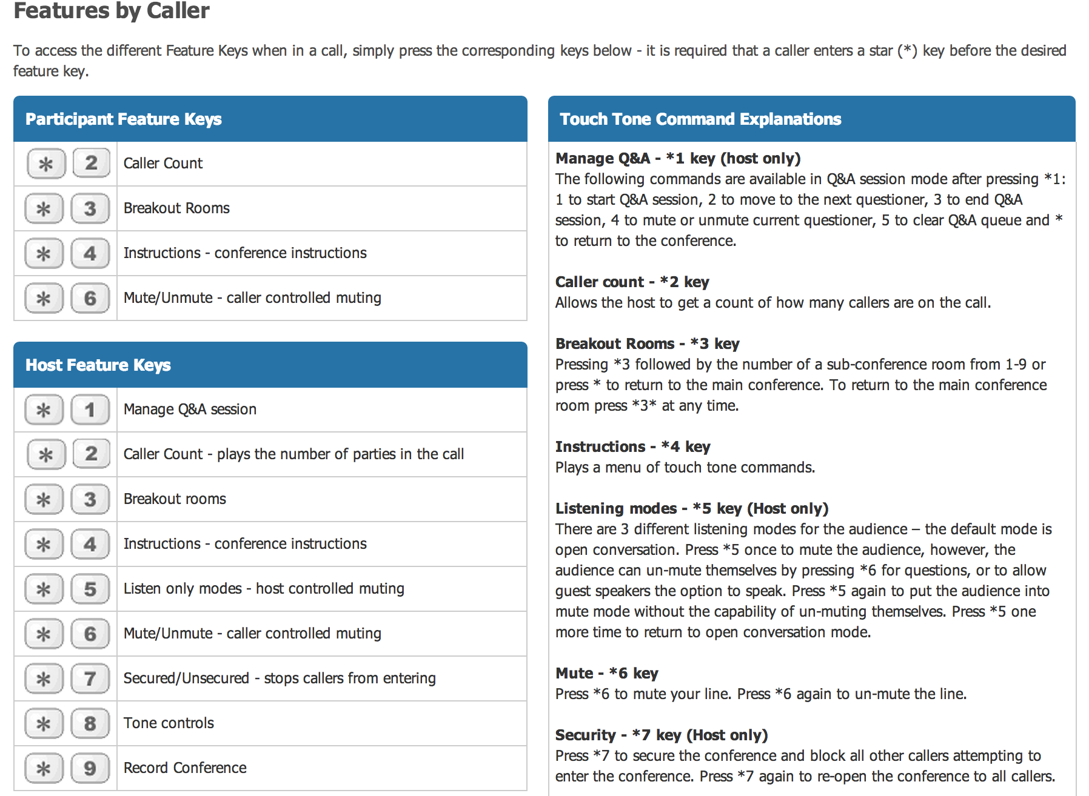

Once you have created an account on their website you will be given three important numbers: A Dial-in Number, Meeting ID, and Host PIN. Our file *CallActiivity.java* already has an existing account hardcoded in but it is easy to modify to any conference. About ¾ of the way down the file you will see a method header entitled *onClick(View view)*, this is where you will change the numbers. Please examine the picture on the next page outlining where each number should go.

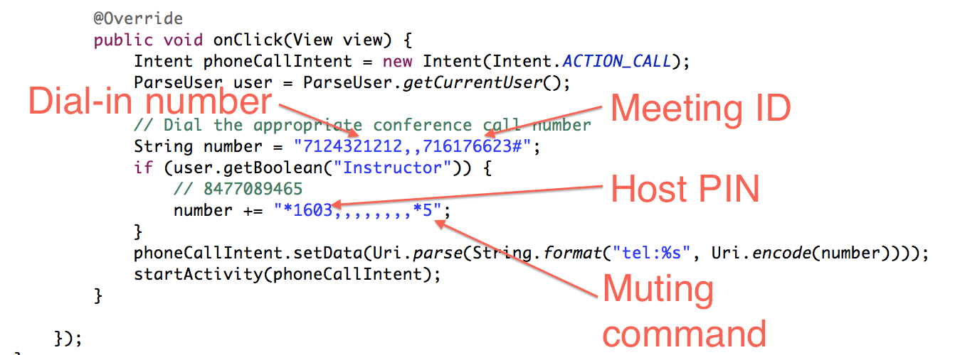

Database Specifications

We used Parse for our database and we only had two objects, a User object and a Question object. Each had the following fields:

User:

* “objectId” – *String*🡪 Unique id for specific object
* “username” – *String*🡪 username for logging in
* “password” – *String*

🡪 password for logging in

* “Instructor” – *Boolean*🡪 flag stating whether or not the user is an Instructor

Question:

* “objectId” – *String*

🡪 Unique id for specific object

* “createdAt” – *Date*

🡪 time at which the object was created

* “custom” – *Boolean*

🡪 flag stating whether or not the question is custom

* “updatedAt” – *String*

🡪 Time at which the question was updated

* “text” – *String*

🡪 text of the question